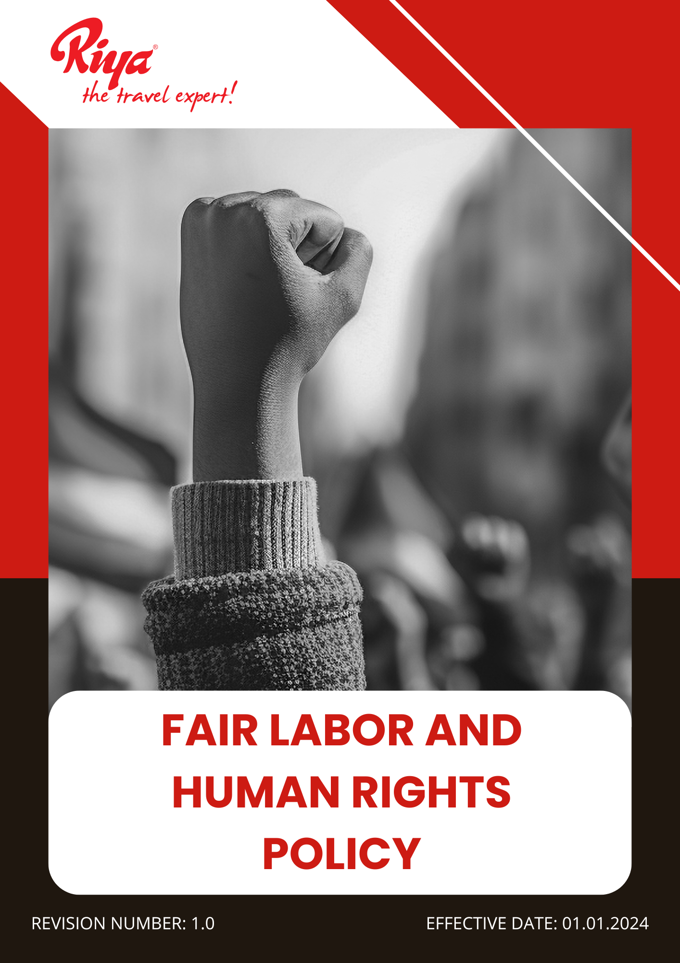

Contents
~ Overview 3
~ Purpose 3
~ Applicability 4
~ Policy statement 4
~ Our Focus Areas 4
~ Our Strategic Approach 4
~ Governance of this Policy 8
~ Responsibility for this Policy 8
~ Reporting 9
~ Continuous Improvement 10
~ Review Mechanism for this policy 10
~ Employee Acknowledgement Form 11

Overview
At Riya Travels and Tours Pvt Ltd (Group), we are committed to upholding fair labor standards and respecting human rights across all our operations. We recognize the importance of providing a safe, inclusive, and respectful work environment where all employees are treated with dignity and fairness. Our commitment includes ensuring equal opportunities, fair wages, non-discrimination, and protection from forced and child labor. We adhere to international labor standards and applicable regulations, promoting ethical employment practices and safeguarding the fundamental rights of our employees and stakeholders. This policy outlines our approach to integrating labor and human rights principles into our business practices, reinforcing our dedication to ethical and responsible operations.

Purpose
- Ensure compliance with local labor and human rights regulations, maintaining high ethical standards.
- Ensure a safe and healthy workplace by implementing robust health and safety management systems and providing employees with necessary training and protective measures.
- Maintain fair and ethical working conditions, including reasonable working hours, adequate rest periods, and equitable wages that align with living standards.
- Foster open social dialogue by encouraging transparent communication between employees, management, and relevant stakeholders to address workplace concerns effectively.
- Promote equal opportunities in recruitment, training, and career advancement, ensuring a merit-based and unbiased approach.
- Support career growth and employee development through continuous training, mentorship programs, and professional development opportunities.
- Prohibit child labor, forced labor, and human trafficking by adhering to international labor standards and ensuring strict compliance across our operations and supply chains.
- Promote diversity, equity, and inclusion by creating an inclusive workplace that values individuals regardless of gender, race, ethnicity, age, disability, or background.
- Establish clear guidelines for reporting and addressing labor and human rights violations, ensuring accountability and transparency.

Applicability
This Fair Labour and Human Rights Policy is applicable across all operations, business functions, and services of Riya Travel and Tours (India) Pvt Ltd (Group), covering all global locations, including corporate offices, registered offices, branch locations, subsidiaries, joint ventures, and associated supply chain activities. It applies to all employees, workers, contractors, and stakeholders connected to Riya Travel and Tours (India) Pvt Ltd (Group), whether directly or indirectly, and mandates strict adherence and accountability at every level.

Policy statement
Riya Travels and Tours Group is dedicated to upholding fair labor practices and protecting human rights in all aspects of our business. We are committed to ensuring a safe, inclusive, and respectful workplace where all employees and stakeholders are treated with dignity, fairly compensated, and provided equal opportunities. By promoting ethical employment practices and partnerships with responsible suppliers, we strive to create a work environment that values human rights and social responsibility.

Our Focus Areas
- Ensuring compliance with labor laws and human rights standards in all business operations.
- Ensuring fair compensation, working hours, and benefits for all employees.
- Preventing discrimination, harassment, and unfair treatment in the workplace.
- Upholding employee health, safety, and well-being as a fundamental priority.
- Prohibiting forced labor, child labor, and any form of exploitation.
- Promoting equal opportunities and diversity across all levels of the organization.
- Respecting employees’ rights to collective bargaining and freedom of association.

Our Strategic Approach
- Employee Health and Safety Management
- We are committed to implementing a comprehensive workplace safety program to ensure that all offices and operational sites comply with health and safety regulations, aiming to eliminate workplace incidents FY 2027-28 from the baseline year FY 2022-23 which is zero.
- Regular safety audits and risk assessments will be conducted across all locations to identify and address potential hazards, ensuring 100% compliance with occupational health and safety standards by FY 2027-28.
- To foster a supportive work environment, mental health awareness, stress management, and employee wellness programs will be introduced, aiming for 100% workforce participation in well-being initiatives by FY 2027-28.
- Access to preventive healthcare services, including annual health check-ups will be expanded to improve employee health outcomes, targeting 100% employee coverage by FY 2027-28 from the baseline FY 2022-23.
- By conducting regular health and safety and first-aid training programs, we aim to strengthen safety awareness and reduce response time during emergencies, ensuring 100% workforce participation by FY 2027-28 from the baseline FY 2022-23.
- Workplace Conditions and Environment
- We are committed to ensuring compliance with labor standards across all operations by strengthening internal policies and monitoring mechanisms, targeting 100% compliance by FY 2027-28 from the baseline FY 2022-23.
- Employee satisfaction surveys on overall working conditions will be conducted annually to identify improvement areas, aiming to achieve an 80% satisfaction rate by FY 2027-28 from the baseline FY 2022-23.
- We are committed to promoting a healthy work-life balance by encouraging flexible working hours and respecting personal time, aiming to increase employee satisfaction levels by 20% by FY 2027-28 from the baseline year FY 2022-23.
- Comprehensive healthcare plans, including medical insurance and mental health support, will be provided to all employees, targeting 100% employee coverage by FY 2027-28 from the baseline FY 2022-23.
- Paid parental leave, childcare support, and wellness benefits will be expanded to support employee well-being, with a target of 100% employee access by FY 2027-28 from the baseline FY 2022-23.
- Employee health insurance plans will be enhanced to ensure comprehensive coverage, targeting 100% employee inclusion by FY 2027-28 from the baseline FY 2022-23.
- Social Dialogue and Employee Engagement
- We are committed to fostering open and transparent communication between management and employees to enhance mutual trust and cooperation, aiming to achieve 100% employee engagement in regular feedback sessions by FY 2027-28.
- Employee engagement feedback sessions will be conducted biannually to promote open communication and collaboration, targeting 80% employee participation by FY 2027-28 from the baseline FY 2022-23.
- We will enhance the employee representative process by defining transparent selection criteria and conducting regular engagement meetings, ensuring that 100% of employee groups have active representation by FY 2027-28 from the baseline FY 2022-23.
- By strengthening collective bargaining agreements and actively engaging with employee representatives, we aim to achieve 100% employee inclusion in the collective bargaining process by FY 2027-28 from the baseline FY 2022-23.
- An anonymous reporting mechanism will be strengthened to allow employees to voice concerns freely, ensuring confidentiality and accountability in all workplace matters.
- Career Development and Training
- A structured career development framework is being introduced to enhance job satisfaction and retention, with a target of 100% employee participation in career planning sessions by FY 2027-28 from the baseline FY 2022-23, ensuring every employee feels supported and valued.
- To create a highly adaptable workforce, skill enhancement and leadership training programs are planned to cover 100% of eligible employees by FY 2027-28, empowering them to excel in their roles.
- An employee mentorship program is set to drive professional growth and knowledge sharing, aiming for 80% employee engagement by FY 2027-28 to accelerate career progression and internal mobility, creating a strong culture of collaboration.
- We aim to ensure that 100% of employees receive a structured performance evaluation annually by FY 2027-28 to drive continuous improvement and career growth.
- Prevention of Child Labor, Forced Labor, and Human Trafficking
- We strictly prohibit child labor, forced labor, and human trafficking across all operations and supply chains, aiming to achieve 100% compliance with international labor standards by FY 2027-28.
- We will implement a robust supplier screening and monitoring program to identify and eliminate risks of child labor and forced labor, with a target of screening 100% of Tier 1 suppliers by FY 2027-28 from the baseline year 2022-23.
- Comprehensive training on identifying and preventing child labor, forced labor, and human trafficking will be conducted for all employees and suppliers, aiming for 100% workforce participation by FY 2027-28 from the baseline 2022-23.
- We will establish a grievance mechanism to enable employees and suppliers to report violations related to child labor and forced labor confidentially, with a target of resolving 100% of reported cases within 60 days by FY 2027-28.
- We will establish a comprehensive internal audit program to assess compliance with labor standards, targeting at least 2 internal audits across all operational locations annually by FY 2027-28.
- Diversity, Equity, and Inclusion (DEI) Initiatives
- Recruitment, promotion, and compensation processes will be structured to provide equal opportunities for all employees, regardless of gender, race, ethnicity, disability, or background.
- Promoting a diverse and inclusive workplace remains a key focus, with efforts to strengthen unbiased recruitment, retention, and promotion practices, aiming to achieve 40% representation of underrepresented groups in the workforce by FY 2027-28 from the baseline year FY 2022-23.
- Efforts to increase the representation of women and minority groups in leadership positions will be reinforced, targeting at least 10% of leadership roles to be held by women or individuals from underrepresented groups by FY 2027-28 from the baseline year FY 2022-23.
- A zero-tolerance policy on discrimination and harassment will continue to be enforced across all operations, with improved response mechanisms to ensure 100% resolution of reported cases within 30 days by FY 2027-28 from the baseline year FY 2022-23.
- Inclusive leadership training will be provided to all managers and senior leaders, ensuring 100% participation by FY 2027-28 to promote unbiased decision-making and equitable workplace culture.
- Employee resource groups and mentorship programs will be established to support underrepresented groups and enhance professional development opportunities.
- Discrimination And Harassment
- Anti-discrimination and anti-harassment training will be expanded to cover all employees and management, with a target of achieving 100% participation by FY 2027-28 from the baseline year FY 2022-23.
- Anonymized reporting tools and support channels for discrimination and harassment cases will be expanded, aiming for a 50% increase in employee usage by FY 2027-28.
- All reported discrimination and harassment incidents will be investigated within 7 working days, with a target of 95% adherence by FY 2027-28 from the FY 2022-23 baseline.
- Regular workplace culture audits will be introduced to proactively identify discrimination risks, targeting completion across 100% of departments annually by FY 2027-28.

Governance of this Policy
The governance of this Fair Labour and Human Rights Policy will be overseen by the Human Rights and Labour Compliance Officer. This individual will be responsible for ensuring compliance with fair labor standards, monitoring workplace conditions, and safeguarding employee rights. They will collaborate with HR, management, and external stakeholders to enforce ethical labor practices, address grievances, and implement best practices in employee welfare. Regular audits, training sessions, and policy updates will be conducted to promote continuous improvement. The Human Rights and Labour Compliance Officer will be accountable for integrating fair labor principles into corporate policies and ensuring a workplace culture that values dignity, equality, and respect for human rights.

Responsibility for this Policy
- Human Rights and Labour Compliance Officer
- Responsible for overseeing and review the implementation of the policy.
- Oversees and reviews the implementation of the policy.
- Collect data and tracks progress on fair labor practices and compliance with human rights standards.
- Ensures corrective actions are taken when violations occur.
- Senior Management
- Provides leadership in ensuring fair labor practices are integrated into corporate decision-making.
- Allocates necessary resources to maintain compliance with labor laws and ethical employment practices.
- Employees
- Expected to respect workplace diversity, human rights, and fair treatment of colleagues.
- Participate in training on fair labor standards and ethical workplace behavior.
- HR Department
- Ensures fair hiring, compensation, and working conditions.
- Implements grievance redressal mechanisms for employees.
- Procurement and Supply Chain Teams
- Ensures suppliers comply with fair labor practices and human rights regulations.
- Conducts regular assessments to ensure ethical labor standards in supply chain operations.

Reporting
- Internal Reporting
- The Human Rights and Labour Compliance Officer will submit quarterly reports to senior management on compliance, employee welfare initiatives, and challenges faced.
- HR and department heads will provide updates on workplace conditions and corrective actions taken.
- Compliance Reporting
- Regular audits will be conducted to monitor adherence to labor laws and corporate commitments to human rights.
- Any violations or grievances will be documented, investigated, and resolved appropriately.
- External Reporting
- An annual Fair Labour and Human Rights Report will be published, outlining the company’s efforts to uphold ethical labor practices.
- Reports will be shared with stakeholders, regulatory bodies, and business partners.
- Employee and Stakeholder Feedback
- A reporting system will be in place for employees and stakeholders to raise concerns about labor rights violations.
- Feedback will be regularly reviewed and used to improve labor policies and practices.

Continuous Improvement
We are committed to continuously enhancing our fair labor and human rights initiatives. Regular assessments of our employment practices, workplace conditions, and supply chain labor standards will be conducted to ensure compliance with international labor laws and ethical employment principles. Through employee training, policy enhancements, and stakeholder engagement, we will foster a work environment that promotes dignity, equality, and respect for human rights.

Review Mechanism for this policy
The Human Rights and Labour Compliance Officer will review this policy every year or as needed to maintain its effectiveness. In collaboration with HR, senior management, and key stakeholders, they will assess compliance, review workplace policies, and make necessary improvements based on regulatory updates, industry standards, and employee feedback. Adjustments will be made to ensure continued alignment with fair labor principles and corporate social responsibility commitments.

Effective Date: 01.01.2024
Last Review Date: 01.01.2025
Next Review Date: 01.01.2026

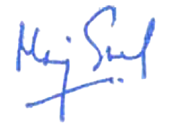

Approved By – Director HR
(Riya Travels and Tours (India) Pvt ltd (Group))

Employee Acknowledgement Form
I acknowledge that I have received, read, and understood the Fair Labour and Human Rights Policy. I understand my responsibility to comply with the policy’s guidelines and to contribute to a workplace culture that values fairness, inclusion, and respect for human rights. I commit to ensuring ethical labor practices, promoting equal opportunities, and maintaining a safe and respectful work environment. I also recognize that the policy will be reviewed periodically, and I will stay informed about any updates. By signing this form, I confirm my commitment to upholding the principles outlined in the policy.

Employee Name: Mr. Mohit Chauhan
Department: Technology
Designation: Manager
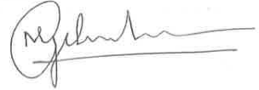
Date: 06/01/2025
Signature:

